Viewpoint instructions are also available in video [How to Use Teradata Viewpoint and SQL Scratchpad](https://www.coursera.org/learn/analytics-mysql/lecture/s7qtE/how-to-use-teradata-viewpoint-and-sql-scratchpad).

Viewpoint is a Web-based portal to the Teradata Database System at the University of Arkansas, access to which is being donated by University of Arkansas to the students in our MOOC. We will use Viewpoint to complete database queries that will serve as the basis for some ungraded exercises, as well as the graded quizzes in this course.

Getting Login Information

1. Obtain a login and password to the ViewPoint system by visiting <https://duke.qualtrics.com/jfe/form/SV_3L4dhh7H4QnhxoF> and entering your Coursera email address (the email you use as your Coursra login). A Viewpoint username and password will be displayed on the screen, and will be emailed to you. Do not share this with anyone; this is provided for you as a learner in this Coursera course only.

Logging into ViewPoint

1. Visit [http://uatdviewpoint.waltoncollege.uark.edu](http://uatdviewpoint.waltoncollege.uark.edu/), enter your username and password, and click the Log In button to open Viewpoint. Note that login and password are CASE SENSITIVE so please be sure to use capital and lower case letters as appropriate.
2. After login, you should see an interface with at least two parts ("portlets": "SQL Scratchpad" and "Object Browser"). **If you don’t see “SQL Scratchpad” and “Object Browser”** as in the image below, do the following steps:

* Click “Add Content” in the upper left, select “SQL Scratchpad” and then click “Add” on the upper right.
* To display the Object Browser if it's not visible to you, in the upper right corner of the SQL Scratchpad window, click the icon with three small horizontal lines to open the portlet menu, and select “Maximize.”
* At this point, you should have a display as in the below image.

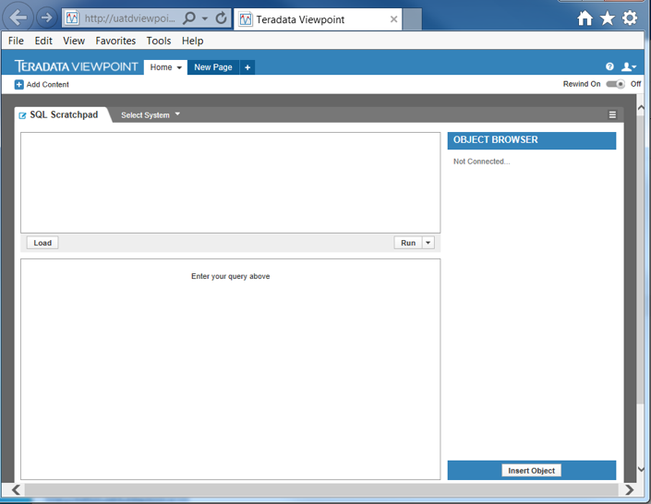

Accessing the Dillard's database within Viewpoint

1. Click the Select System drop down and select UATD.

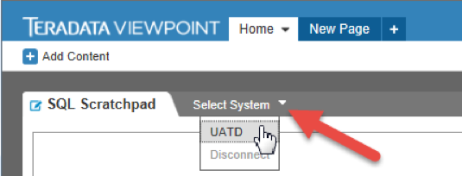

2. Re-enter your credentials for access to the UA Teradata System.

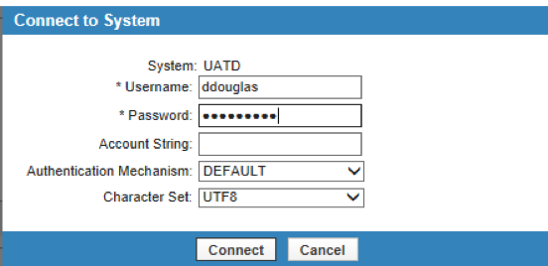

3. In the Object Browser on the right, expand the UATD entry, if necessary, by clicking the + button beside UATD. Enter ua_dillards in the text box, and the two entries shown below should appear.

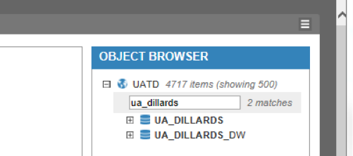

You may expand the display for details (click the + button) next to ua_dillards database. You will note that ua_dillards has 7 tables.

Running queries in the Dillard's database

To query the Dillard’s database, enter your queries in the top left panel under “SQL Scratchpad” (the query panel) and the results will appear in the bottom left panel (the results panel).

Sample queries using the SQL Scratchpad:

1. To establish ua_dillards as the default database so you will not have to qualify (prefix) queries and table names with ua_dillards, enter the following SQL statement in the SQL Scratchpad query panel (top left panel):

Database ua_dillards;

Click the “Run” button at the bottom right of the SQL Scratchpad query panel to run the query. The result will display in the results panel (bottom left panel) and should show: 0 rows processed

2. Enter the following SQL statement and run it.

Select count(*) from trnsact;

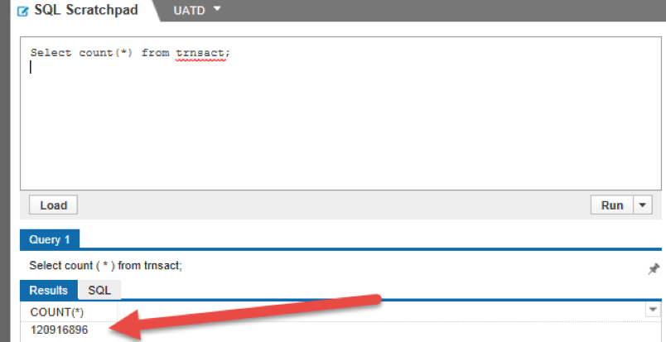

The default database should remain ua_dillards until changed; of course, you can qualify tables with the database name at any time.

3. By default, only one SQL statement can be executed at a time. However, note the Run button has a drop-down menu with one option being "Run Selected Query". This allows you to select multiple queries at once and run them all. For example, run the following two SQL statements by entering them into the query panel, selecting them with your mouse, and then selecting “Run Selected Query” from the Run drop-down:

DATABASE ua_dillards;

SELECT str.state, str.city, sku.dept, SUM(t.amt) AS Total_Sales

FROM strinfo str, skuinfo sku, trnsact t

WHERE t.store=str.store AND t.sku = sku.sku

GROUP BY str.state, str.city, sku.dept

ORDER BY str.state, str.city, sku.dept

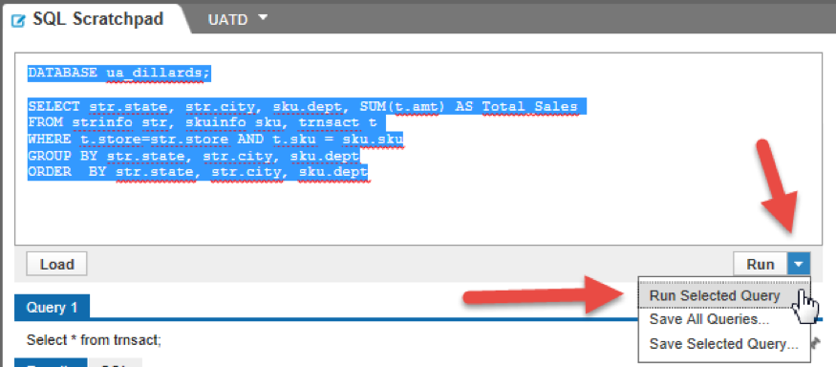

Note The result includes two tabs: Query 1 (which should say “0 rows processed”) and Query 2 (which has the results of the 1st and 2nd query).

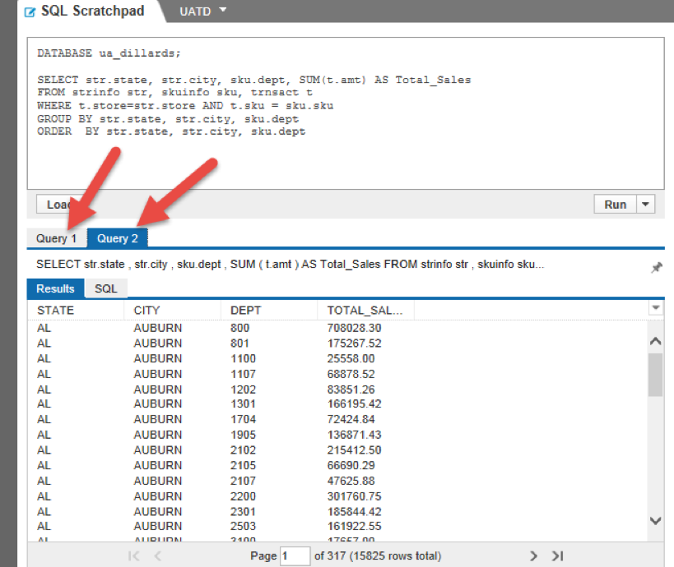

Getting help with Viewpoint

To get help with Teradata Viewpoint or the SQL Scratchpad portlet:

* From within Viewpoint or from the main login screen, click the ? button at the top right.
* In the Viewpoint help window that opens, click the + to expand “Teradata Viewpoint” on the left.
* In the expanded menu, click on SQL Scratchpad, which will open a help page for SQL Scratchpad on the right.
* If you are unable to find an answer for your question, please look through the "[Guidance to Writing Queries](https://www.coursera.org/learn/analytics-mysql/resources/DuiMb)" resource page and/or the "[Troubleshooting Teradata](https://www.coursera.org/learn/analytics-mysql/resources/s9VHI)" resource page.